**shatteredmysteries.com**

Shattered Mysteries is a point and click adventure game designed and developed by two creative individuals where a ratty detective must scour a mysterious island inhabited by eccentric criminals to find her friend’s missing amulet.

Inspired by the Nancy Drew games by Her Interactive, developer Long Gate aims to captivate its audience with a fun and fantastical point and click adventure/mystery game. The player plays as freelance detective Natasha Grazun, who was hired by her friend to find a family heirloom which was stolen. The gameplay consists of exploring the island of Oar, discovering and inspecting clues, interrogating the inhabitants, and trying to avoid death and danger at every turn. With an island full of criminals, anyone could be a suspect. It’s up to the player to bring the truth to light and return the missing amulet in Shattered Mysteries.

# Personas

Senior Producer

Publisher representative who can help distribute the game physically

Point and Click Adventure Fan

Plays point and click adventure games and will find interest the game

# Comps

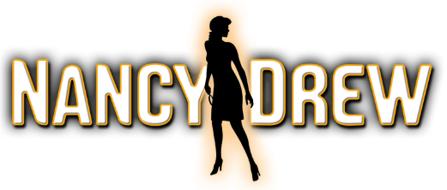 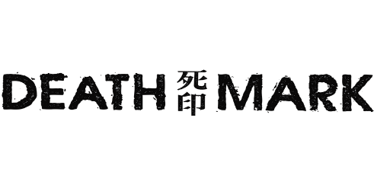 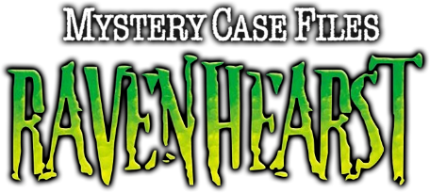

# Wireframes

The first wireframe was created with pencil and paper. Pictured below is a rough sketch of the two pages for the site. The home page has a column of sections about the game the website houses information about. The sections are about the story, the gameplay, the setting, the characters, and the product information. The ordering of the sections was not yet decided at this beginning point.

The characters page has less information and is solely about the different characters in the game. The user can click the arrows to read about each character. The game’s genre is mystery, so for the characters page the information is on top of a file image to fit with the theme. The user can access this page from the nav bar on the top or by clicking on a button on the home page to navigate.

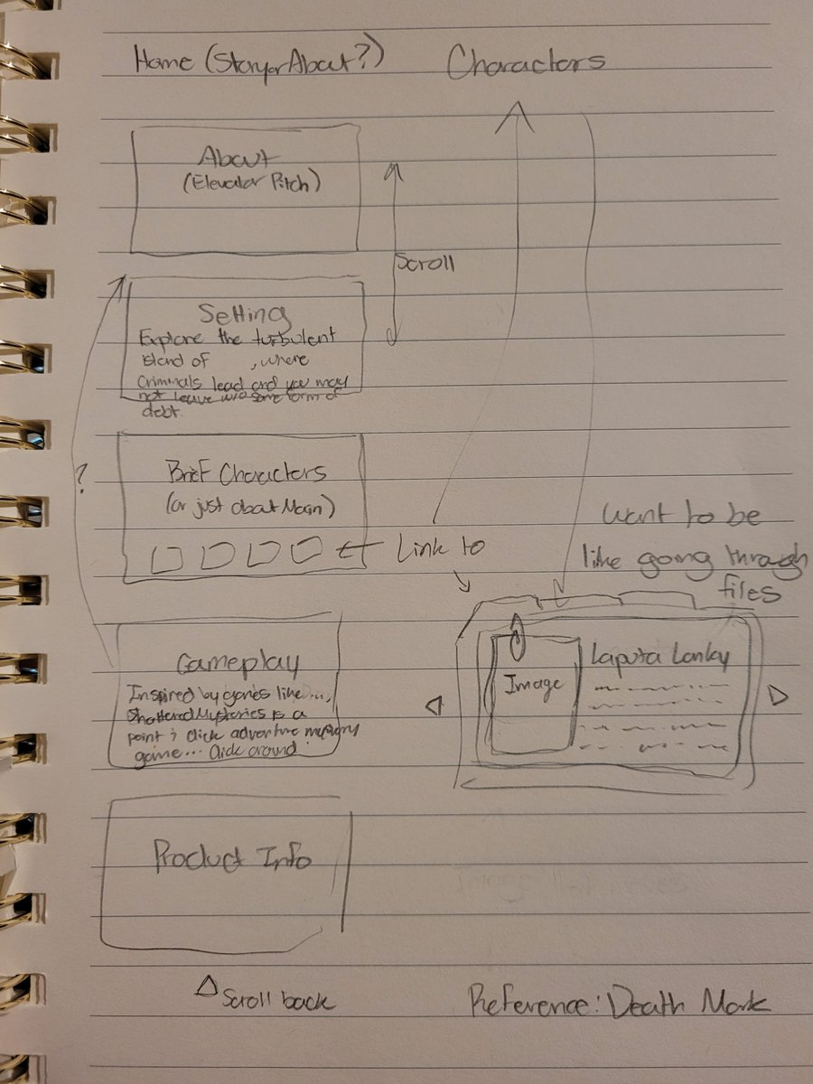

The wireframes below were created using Figma. The digital wireframes follow the rough sketch.

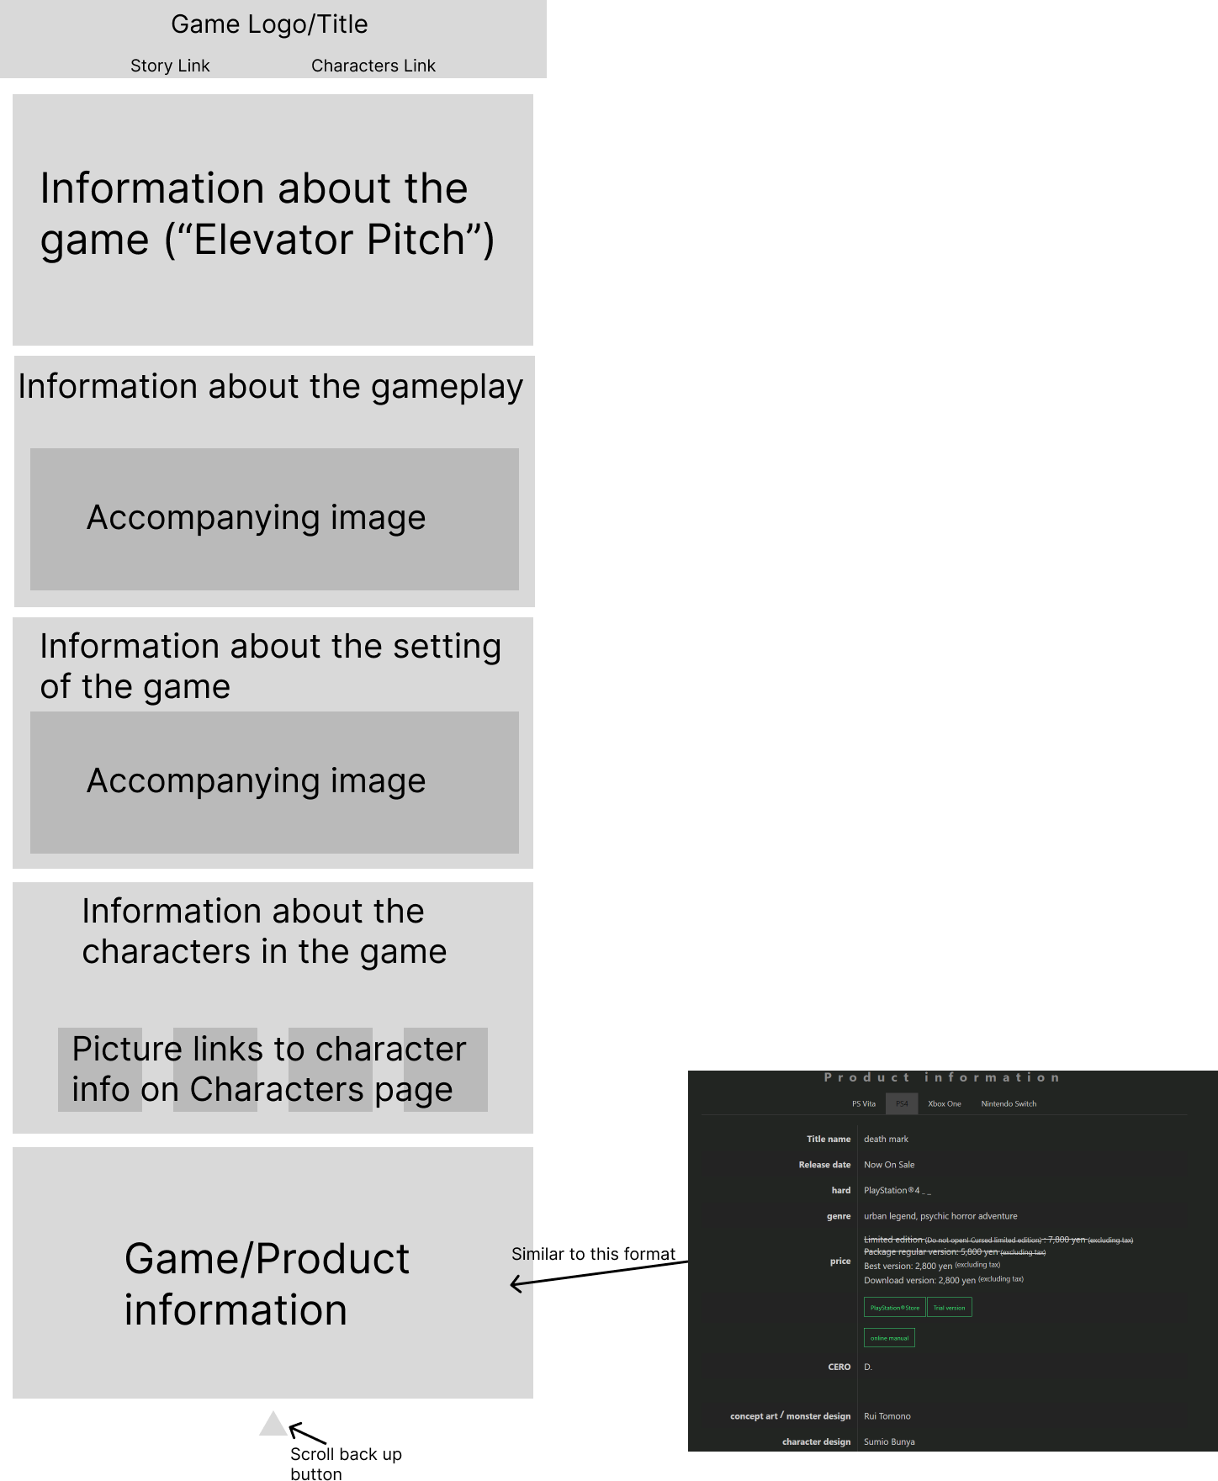

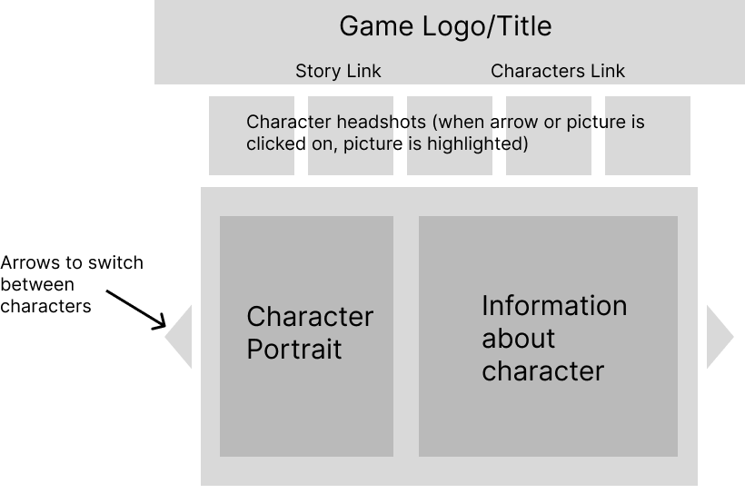

Color was added to the wireframe to determine a color scheme. The website’s colors are to be similar to the game’s theme colors which are black and red.

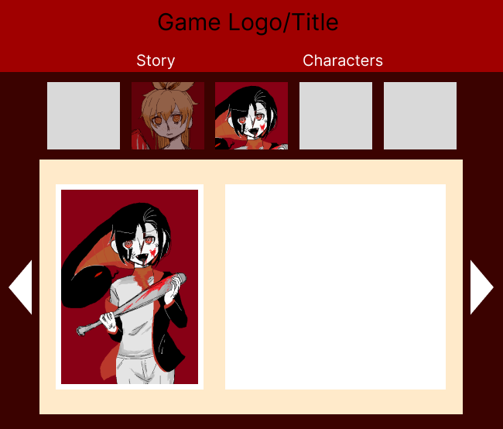



#FF0000 #A00000 #3C0200

# Assets

The logo is created by the game’s writer, William Long.



Images of the characters and custom image assets are created by the game’s character designer, Gatesana Vongphachanh. The images featured on the site are to represent the art style and tone of the game.

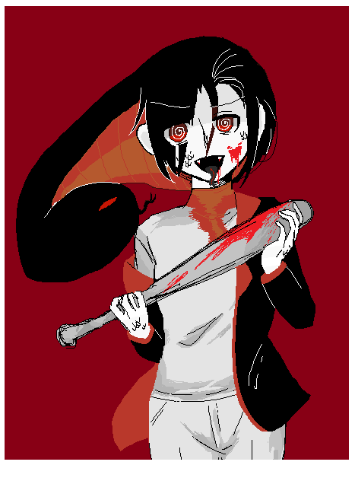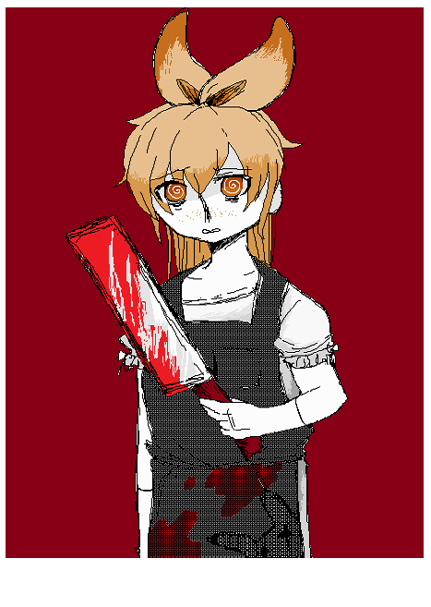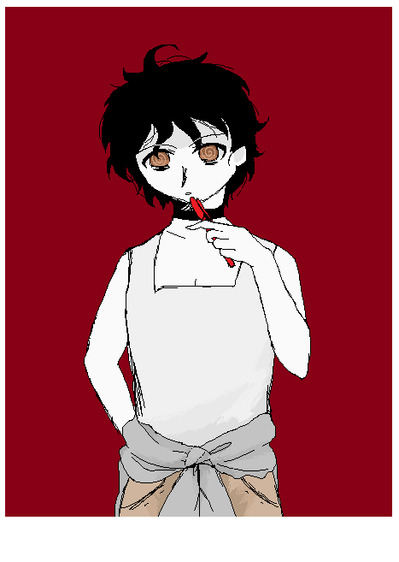

The only asset used that was not custom made is the file background for the character page.

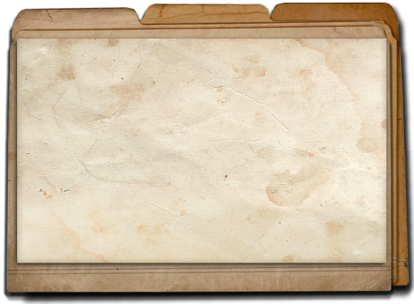

<https://www.pngkey.com/detail/u2q8w7e6w7e6o0o0_old-folder-png-detective-folder/>

# Inspiration

The websites referenced are meant to introduce and advertise a specific game to consumers. As shown below, the websites start with an advertising image before going into the game’s information. Information is displayed in sections and accompanied with an image relating to the text. These elements will be taken into consideration and utilized.

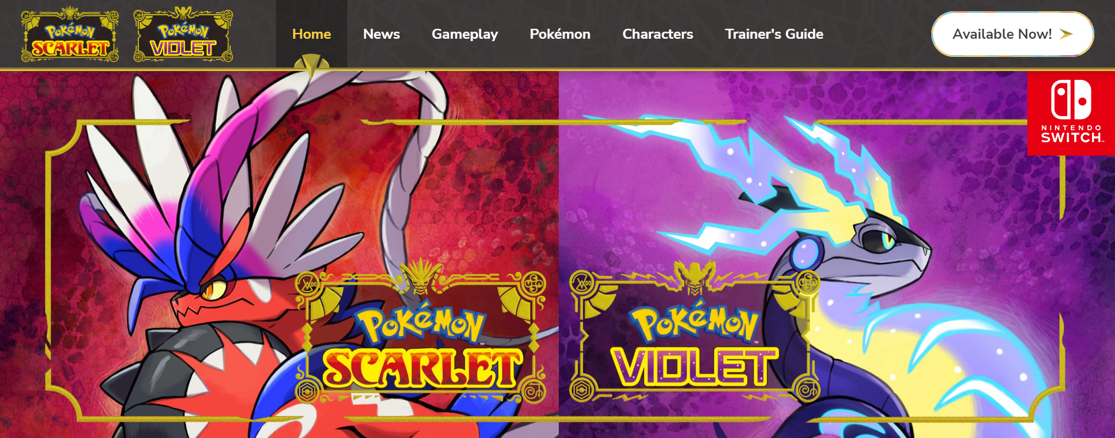

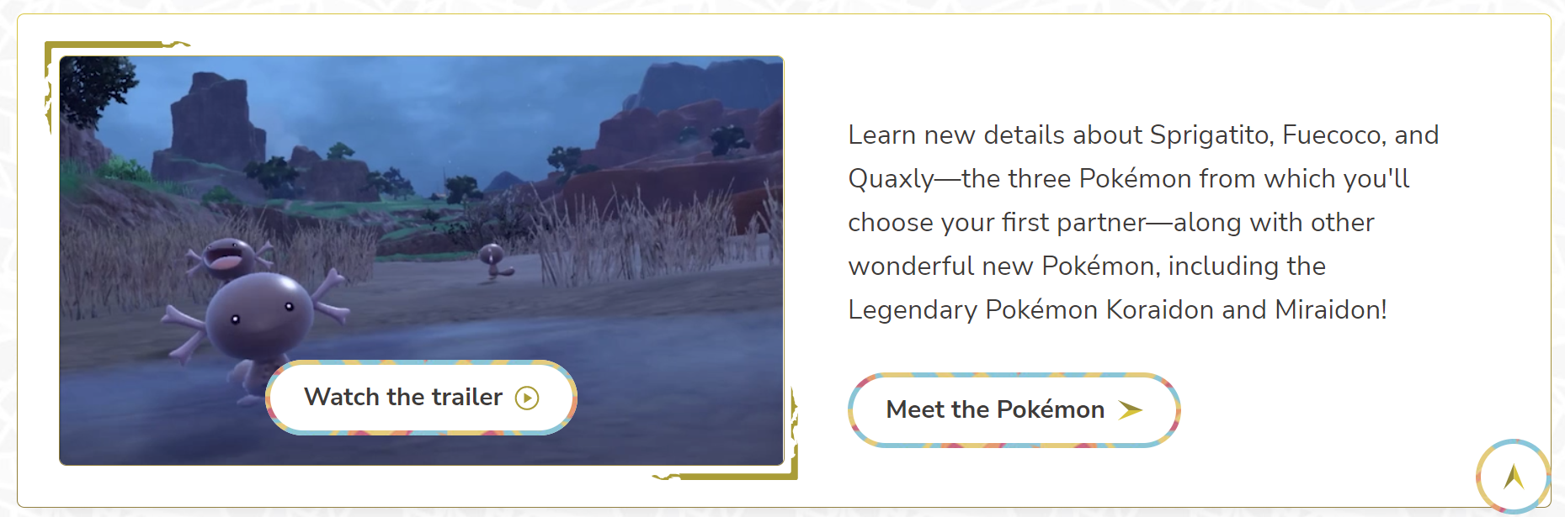

<https://scarletviolet.pokemon.com/en-us/>

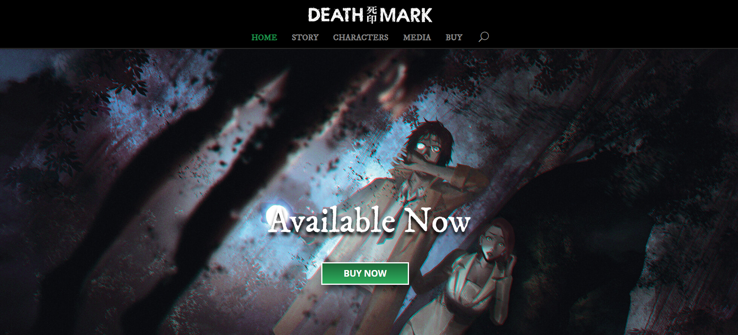

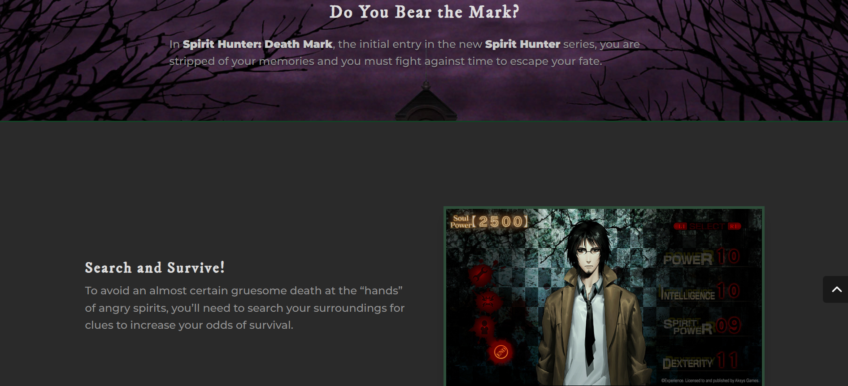

<http://www.aksysgames.com/deathmark/>

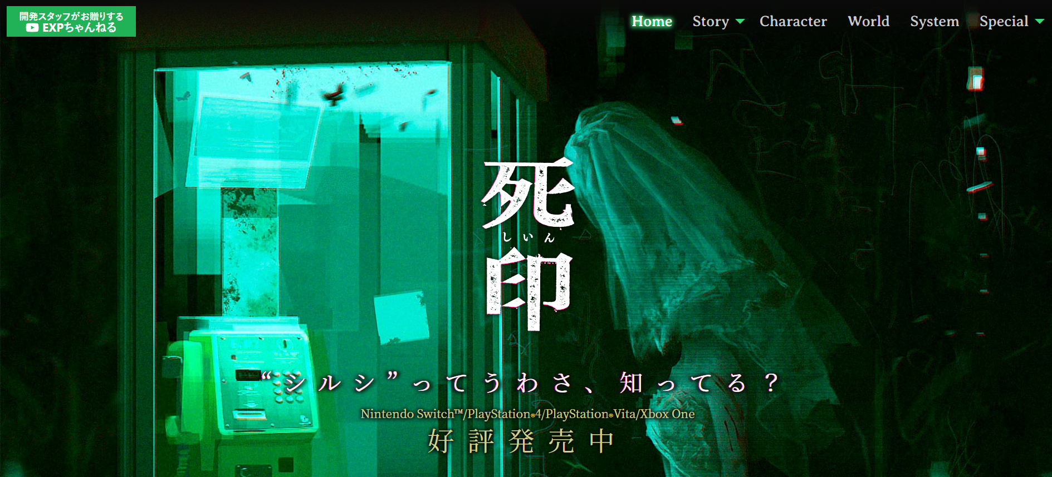

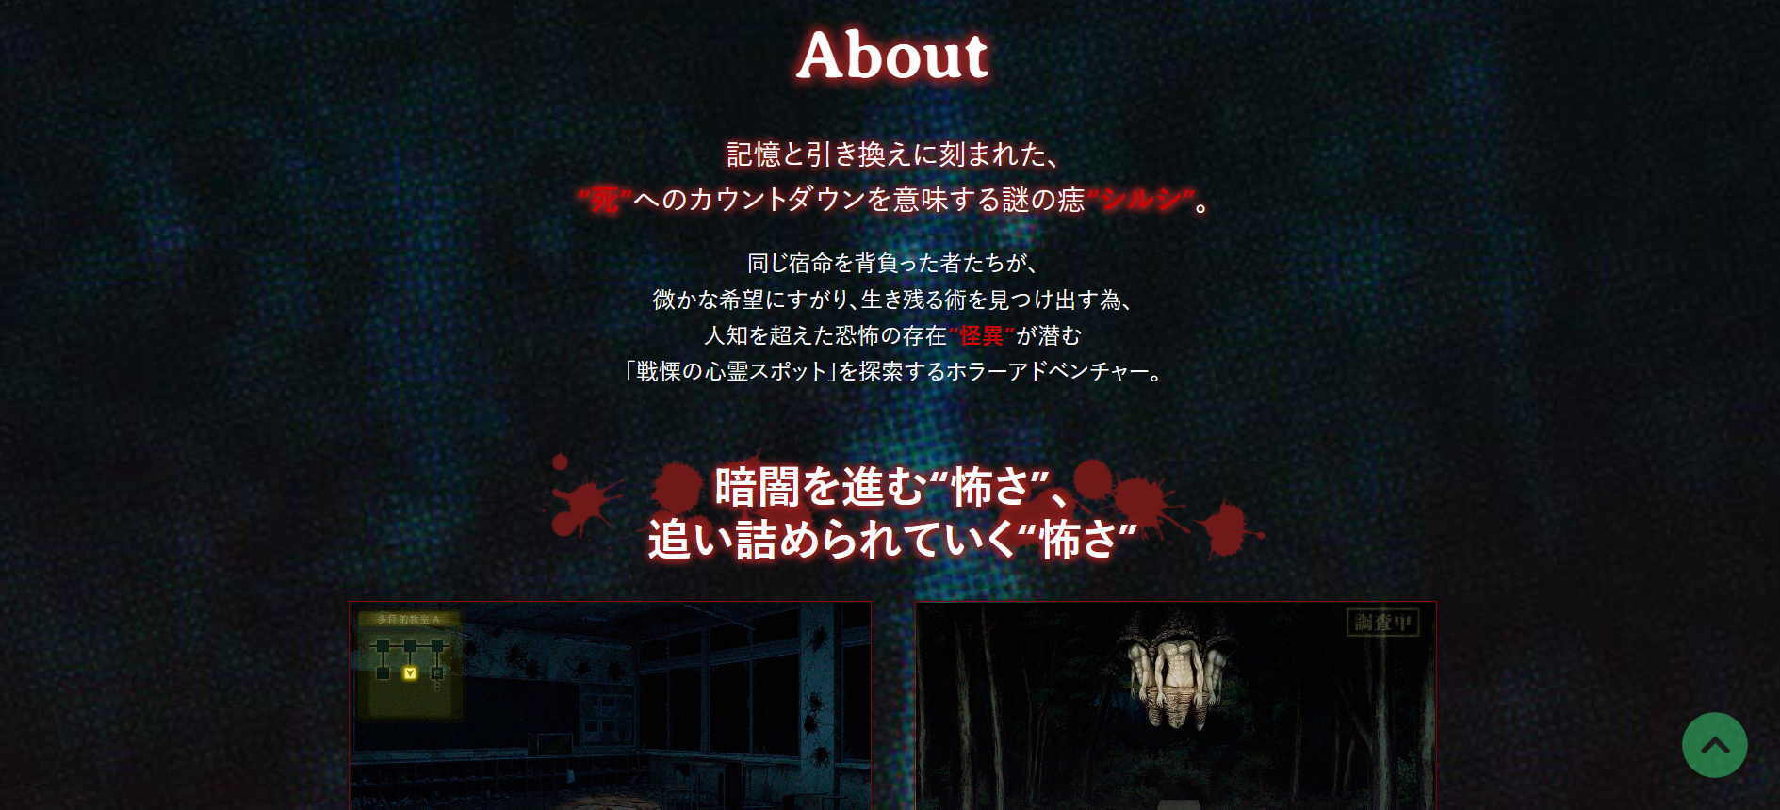

<http://shiin.jp/>